**Methods**

**Temporal Modelling**

Noise levels recorded by the drifters are naturally correlated in space and time so care must be taken in the analysis in order to conflate these effects. In this case large-scale storm systems moved through the survey area affecting ambient noise levels on large scales. Simultaneously, gradually drifted to the southeast. Failing to account for the timing of the storms during the drift could result in models indicating louder noiselessness towards the later, more southeastern part of the drift.

While there are a variety of methodologies that account for spatial and temporal autocorrelation, all rely on multiple measurements at the same location. Because that is not possible with these data, we instead approach the spatial and temporal aspects independently. Temporal analysis included using correlograms to investigate the spatial cohesion of the raw noise levels in the 500 Hz and 20 kHz 1/3rd octave bands.

**Spatial Modelling**

To investigate spatial trends, 60-minute rolling averages were calculated for both bands and the variation above or below was modeled using 2-dimensional smoothing. Spatial modelling of noise level variation was undertaking using a modified version of the MRSEA. The packages uses a Spatially Adaptive Local Smoothing Algorithm (SALSA) to automatically select the number and location of knots for bivariate splines (Scott-Hayward et al. 2021, 2023). The package was modified to allow for haversine distance matrix calculations rather than Pythagorean, the default method.

VIF scores were used to evaluate remaining collinearity between the spatial response, latitude, longitude, and time. The maximum VIF score was 2.05 and deemed acceptable for modelling.

Models were fit using BIC selection and variograms were used to estimate nugget parameters. Parameters for the spatially adaptive two dimensional smooth of spatial coordinates included the minimum and maximum number of knots, 10 and 40 respectively. The gap value was set to 0 and natural cubic splines were chosen to limit edge effects. Gaussian model basis was chosen over exponential as the data here are describe by physical processes of sound propagation which is approximated in deep-water open ocean conditions by a linear process acting on log transformed range (e.g. 15*log(r)). Pearson residuals of the fitted model were plotted against location to check for patterns between the residuals and explanatory variables. K-fold cross validation is used to report model prediction error

**Results**

**Temporal Modelling**

Figure 1shows the 2-minute median noise level in two third octave bins during an 8-day drift near the Morro Bay WEA. Increase in noise levels from two storms are march 14th and 15th that raised baseline noise levels approximately 10 and 20dB re 1µ Pa for the lower and upper third octave band respectively.

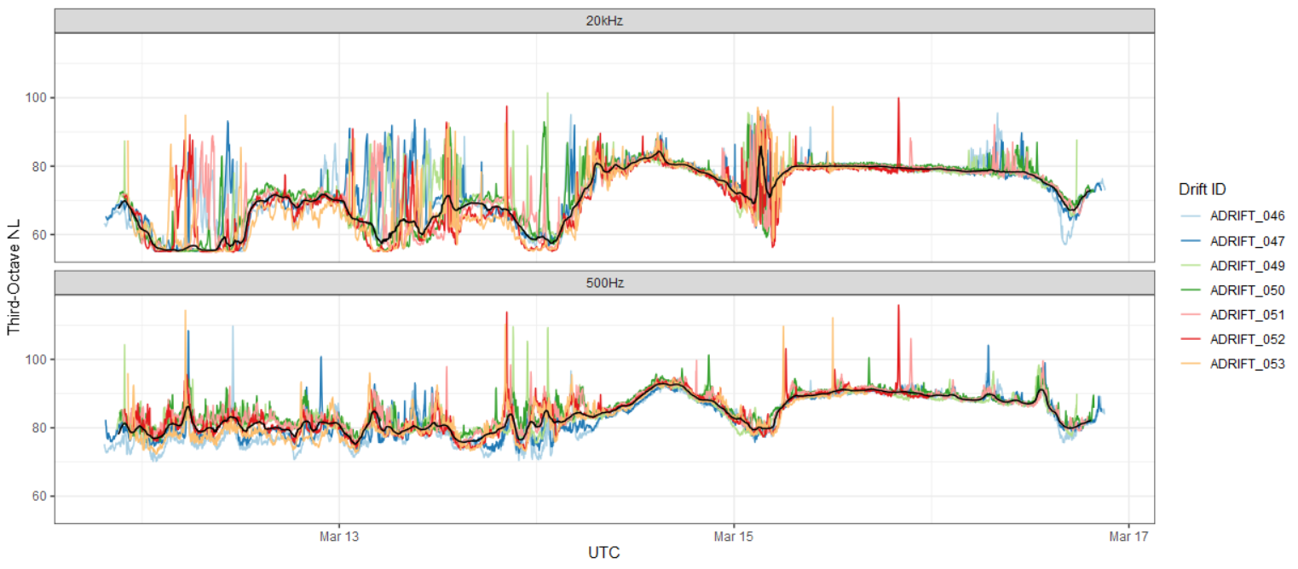

**Spatial Modelling**

**Citation**

Scott-Hayward L.A.S., Walker C.G., Mackenzie M.L. (2021). “Vignette for the MRSea Package v1.3: Statistical Modelling of bird and cetacean distributions in offshore renewable development areas.” University of St. Andrews. Centre for Research into Ecological and Environmental Modelling.

Scott-Hayward, L.A.S., Mackenzie, M.L., Walker, C.G., Shatumbu, G., Kilian, J.W., du Preez, P., 2023. Automated surface feature selection using SALSA2D; An illustration using elephant mortality data in Etosha National Park. https://doi.org/10.48550/arXiv.2202.07977